Minutes of the All-Party Meeting held on 07/02/2023
IQAC Office, 11.00 am
Agenda:
Discussion on the recommendations submitted by IQAC to the Management on implementation of Campus Discipline
Members Present: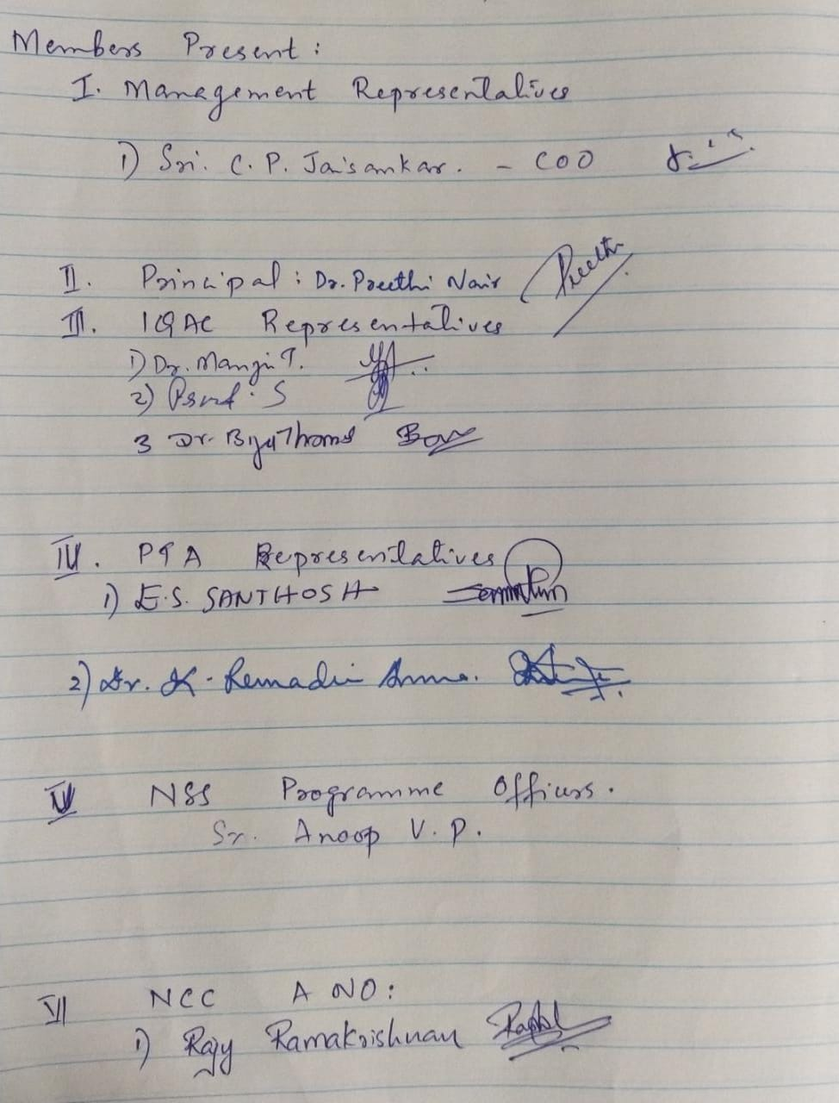
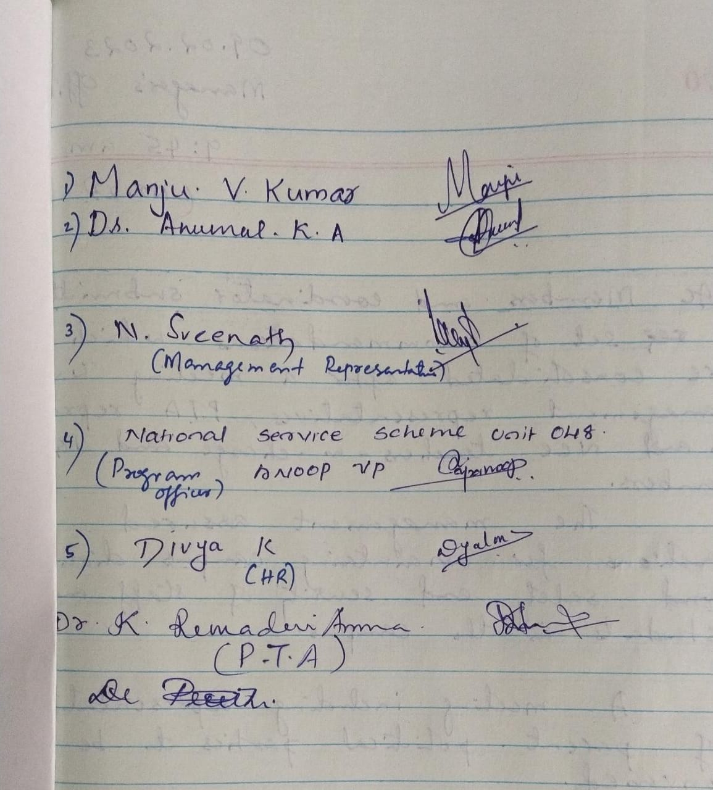

Recommendations for reinstating academic ambience in the campus – 07.02.2023
- Student Politics deviating from Objectives and misleading students towards unscrupulous political agendas
Recommendations
- Seek court orders restricting politics to constructive activities. Gheraos, unnecessary strikes, shouting of slogans using foul language and violent clashes need to be controlled legally.
- Support for enforcing strict action against political campaigns in classes wherein misleading and polluting messages are propagated among students, especially freshers. (e.g., encouraging class bunking in the name of “enjoyment”, encouraging violation of ethics and code of conduct in the name of independence and “liberation”)
- Support to teachers who face threatening calls from political leaders while implementing actions against violation of code of conduct and regulations.
- Deny and discourage admissions to candidates with notorious background and history
- Intruders including former students and antisocial elements even at midnight indulging in in-disciplinary as well as immoral activities
Recommendations
- Seek court orders prohibiting intruders in the campus, including unauthorised vehicles
- Strengthen the security at the gate by assigning efficient personnel (such as ex-service men)
- Strict maintenance of Gate register including purpose of visit, time of entry and exit, by Security at the gate
- Provide adequate lighting in the campus during night time.
- Fixing a day and time every week for former students to avail service from college office such as TC issuing, etc.
- Insecure Campus for students as well as staff
Recommendations
- Maintenance of strict gate register
- Installation of CC-TV cameras
- Street lights as well as lighting in the corridors of the campus buildings
- Efficient and vigilant security forces
- Restrict entry of students/outsiders inside the campus after 5.30 pm and on holidays without prior permission of the authority.
- Infamous corners of drug pedalling and immoral activities
Recommendations
- Seek court orders prohibiting drugs and narcotics usage and pedalling in the campus
- Close the entry to north side of indoor stadium
- Installation of CC-TV cameras at notorious corners such as the north side of indoor stadium, near generator room, near basket-ball court, etc
- Strict implementation of campus timings
- College gates to be locked by 7.00 PM.
- DJ and water drum sessions becoming forums of drug usage and pedalling and violent clashes
Recommendations
- There is already a court order banning DJ and other such paid programmes. Court order specific to the college may be obtained which can be quoted publicly in the campus
- Prohibiting outsiders, and former students to enter campus during programmes conducted specifically for students.

